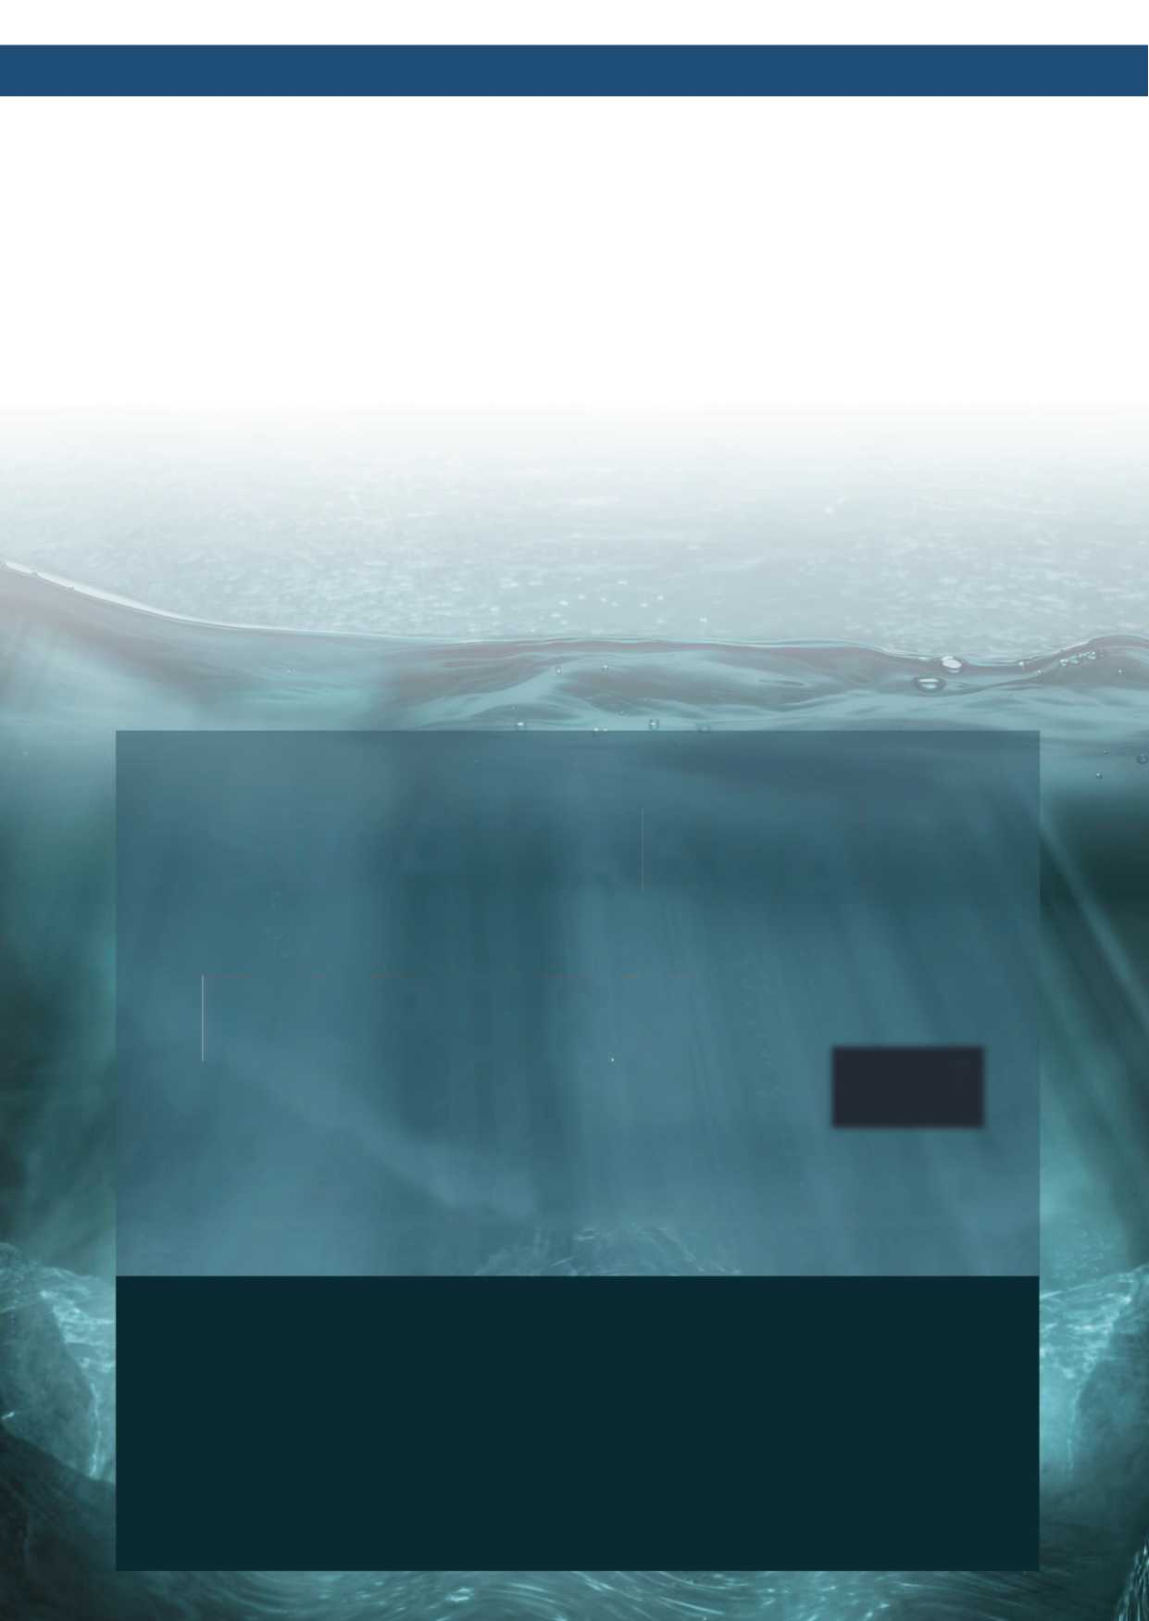

WATER FOOTPRINT REPORT

2025

ISO 14046:2014
Environmental management — Water footprint — Principles, requirements and guidelines

ERTE KOZMETİK SANAYİ VE TİCARET A.Ş.

Table 1 ISO 14046 Water Footprint Report - Basic Information and Responsible Persons
Details of the Report
Report Name | Erte Kozmetik Sanayi ve Ticaret A.Ş.  ISO 14046 Water Footprint Report
Report Preparation Date | 10.04.2026
Report Period | January 1, 2025 - December 31, 2025
Company Details
Trade Name | Erte Kozmetik Sanayi ve Ticaret A.Ş.
Address | Cihangir Mahallesi Güvercin Caddesi No:1 34310  İstanbul/Türkiye
Telephone | +90 (212) 875 81 82
Website | https://ertecosmetics.com
Details of the Responsible Person(s)
Name(s) and Title(s) of Person(s) Responsible for the Report | Pamuk Durak / OHS, Environment and Social Compliance Manager
Contact Details of the Person(s) Responsible for the Report | pamuk.durak@ertecosmetics.com

Blue Water Footprint Calculation Results
Water use sources of the facility were determined as mains water and the purchased drinking water. The blue water footprint for 2025 was calculated as 11,756.84 m³. The facility’s blue water footprint inventory information is presented in Table 2.
Table 2 Blue Water Footprint Inventory Information
Water Source | Surface Water | Purchased Drinking Water | Total Blue Water Footprint
Water Type | Mains Water | Water packed in Carboys, PET Bottles and PET Cups | Mains Water and Purchased Drinking Water
Fields of Use | Basic Production  Processes  Domestic | Drinking Water | Basic Production Processes  Domestic  Drinking Water
Data Source | Meter, Bill | Bill | Meter and Bill
Total (m³/year) | 11,576.96 | 179.88 | 11,756.84

Green Water Footprint Calculation Results
The facility does not have an existing rainwater harvesting system and does not utilize green water. Therefore, the facility’s green water footprint is ‘0’.
Grey Water Footprint Calculation Results
The grey water footprint was calculated using wastewater amount, and the monthly amount of wastewater generated is presented in Table 3.
Table 3 Type and Amount of Wastewater Generated
Months | Industrial (m³) | Domestic (m³) | Total Wastewater Amount (m³)
January | 145.08 | 511.22 | 656.30
February | 174.60 | 595.90 | 770.50
March | 154.58 | 515.25 | 669.83
April | 163.35 | 559.09 | 722.44
May | 155.93 | 532.15 | 688.07
June | 175.73 | 600.89 | 776.62
July | 215.55 | 731.38 | 946.93
August | 182.03 | 621.72 | 803.74
September | 389.70 | 1,315.84 | 1,705.54
October | 210.83 | 713.74 | 924.57
November | 250.88 | 847.69 | 1,098.56
December | 386.59 | 1,299.74 | 1,686.33
TOTAL | 2,604.82 | 8,844.61 | 11,449.43

The grey water footprint of the SS (suspended solids) pollutant parameter discharged as a result of the company’s activities was calculated, and is presented in Table 4.
Table 4 Grey Water Footprint Amount for Suspended Solids
Industrial | Pollutant load | kg/year | 26.05
Industrial | Cmax | mg/L | 200
Industrial | Cnat | mg/L | 0.00
Industrial | Grey water footprint | m³/year | 130.24
Domestic | Pollutant load | kg/year | 1,768.92
Domestic | Cmax | mg/L | 200.00
Domestic | Cnat | mg/L | 0.00
Domestic | Grey water footprint | m³/year | 8,844.61

The grey water footprint of the COD (chemical oxygen demand) pollutant parameter discharged as a result of the company’s activities was calculated, and is presented in Table 5.

Table 5 Grey Water Footprint Amount for Chemical Oxygen Demand
Industrial | Pollutant load | kg/year | 101.59
Industrial | Cmax | mg/L | 250.00
Industrial | Cnat | mg/L | 0.00
Industrial | Grey water footprint | m³/year | 406.35
Domestic | Pollutant load | kg/year | 1,592.03
Domestic | Cmax | mg/L | 180.00
Domestic | Cnat | mg/L | 0.00
Domestic | Grey water footprint | m³/year | 8,844.61

The grey water footprint of the oil and grease pollutant parameter discharged as a result of the company’s activities was calculated, and is presented in Table 6.

Table 6 Grey Water Footprint Amount for Oil and Grease
Industrial | Pollutant load | kg/year | 23.44
Industrial | Cmax | mg/L | 20.00
Industrial | Cnat | mg/L | 0.00
Industrial | Grey water footprint | m³/year | 1,172.17

The grey water footprint of the BOD (biochemical oxygen demand) pollutant parameter discharged as a result of the company’s activities was calculated, and is presented in Table 7.

Table 7 Grey Water Footprint Amount for Biochemical Oxygen Demand
Domestic | Pollutant load | kg/year | 663.35
Domestic | Cmax | mg/L | 75.00
Domestic | Cnat | mg/L | 0.00
Domestic | Grey water footprint | m³/year | 8,844.61

The results of the sensitivity analysis of industrial wastewater values are presented in Table 8, and the results of the sensitivity analysis of domestic wastewater values are presented in Table 9.

Table 8 Results for the Sensitivity Analysis of Industrial Wastewater
Results |  |  | +15% Results |  |  | -15% Results
Total Consumption | 2,894.24 |  | Total Consumption | 3,328.38 |  | Total Consumption | 2,460.10
Discharged Water | 2,604.82 |  | Discharged Water | 2,995.54 |  | Discharged Water | 2,214.09
Pollutant Loads |  |  | Pollutant Loads |  |  | Pollutant Loads
SS | 26.05 |  | SS | 29.96 |  | SS | 22.14
COD | 101.59 |  | COD | 116.83 |  | COD | 86.35
Oil and Grease | 23.44 |  | Oil and Grease | 26.96 |  | Oil and Grease | 19.93

Table 9 Results for the Sensitivity Analysis of Domestic Wastewater
Results |  |  | +15% Results |  |  | -15% Results
Total Consumption | 8,862.60 |  | Total Consumption | 10,191.99 |  | Total Consumption | 7,533.21
Discharged Water | 8,844.61 |  | Discharged Water | 10,171.30 |  | Discharged Water | 7,517.92
Pollutant Loads |  |  | Pollutant Loads |  |  | Pollutant Loads
SS | 1,768.92 |  | SS | 2,034.26 |  | SS | 563.84
COD | 1,592.03 |  | COD | 1,830.83 |  | COD | 563.84
BOD | 663.35 |  | BOD | 762.85 |  | BOD | 563.84

CONCLUSION & ASSESSMENT

When the types and sources of water use for 2025 were examined:
• The blue water footprint was determined to be 11,756.84 m³/year,
• The green water footprint was determined to be 0 m³/year,
• The grey water footprint was determined to be as follows:
Industrial: 1,172.17 m³/year,
Domestic: 8,844.61 m³/year.

The facility meets its water need by using the mains water and the drinking water purchased; sources are regularly monitored through meters and bills. The facility uses 11,756.84 m³ of water in total per year and discharges 11,449.43 m³ of wastewater per year.

The mass balance calculated based on the ISO 14046 Standard is presented in Table 10.

Table 10 ISO 14046 Mass Balance
Water Withdrawal Sources | WATER WITHDRAWAL | Wastewater Discharge Destinations | WATER DISCHARGE
Ground Water (m3/year) | 0.00 | Other Recipient Water Bodies (Sea, Streambed, etc.)  (m3/year) | 0.00
Mains / Surface Water (m3/year) | 11,576.96 |  | 0.00
Other Sources (Sea Water, etc.) (m3/year) | 0.00 | 3rd Party (Sewage Truck, Municipal Sewer)  (m3/year) | 11,449.43
3rd Party Purchases (Carboy, PET Bottle, etc.) (m3/year) | 179.88 | 3rd Party (Sewage Truck, Municipal Sewer)  (m3/year) | 11,449.43
Total Amount of Water Withdrawn (m3/year) | 11,756.84 | Total Wastewater Discharged | 11,449.43
MASS BALANCE (m3/year) |  | 307.41

