

CORPORATE CARBON FOOTPRINT REPORT

TS EN ISO 14064-1:2019
Greenhouse gases — Part 1: Specification with guidance at the organization level for quantification and reporting of greenhouse gas emissions and removals

2025

ERTE KOZMETİK SANAYİ VE TİCARET A.Ş.

NAME OF THE ORGANIZATION | ERTE KOZMETİK SANAYİ VE TİCARET A.Ş.
ADDRESS | Cihangir, Güvercin Caddesi No:1, 34310  Avcılar/İstanbul
TELEPHONE | +90 (212) 875 81 82
WEBSITE | https://ertecosmetics.com
ACTIVITIES | Development and production of perfumes, house fragrances, bath and body care products, and skin care and hair care products
PROJECT DESCRIPTION | Calculation of Carbon Footprint Values within the scope of TS EN ISO 14064-1:2019 and GHG Protocol
PERSON IN CHARGE | Pamuk Durak
REPORT DATE | 13.04.2026
REPORT REVISION DATE | -
REPORT REVISION NO. | 00
FREQUENCY | Once a year
REPORT PERIOD | 01.01.2025-31.12.2025
BASE YEAR | 2022

GREENHOUSE GAS EMISSION RESULTS

Greenhouse gas emissions are presented in Table 1 summary chart.

Table 1 Greenhouse Gas Emissions Summary Chart
Emissions | SF6 | HCFC | CO2 | CH4 | N2O | Total tCO2e
Emissions | (tCOıe) | (tCOıe) | (tCOıe) | (tCO2e) | (tCO2e)
Category 1 | 0.00 | 7.41 | 138.86 | 0.10 | 0.84 | 147.22 | 1%
Category 2 | 0.00 | 0.00 | 468.74 | 2.04 | 2.70 | 473.47 | 4%
Category 3 |  |  |  |  |  | 2,156.54 | 18%
Category 4 |  |  |  |  |  | 9,454.25 | 77%
Category 5 |  |  |  |  |  | 22.64 | 0%
Category 6 |  |  |  |  |  | 0.00 | 0%
Total tCO_{2e} |  |  |  |  |  | 12,254.12 | 100%

Details of distribution of the company’s greenhouse gas emissions by category are shared in Figure 1.

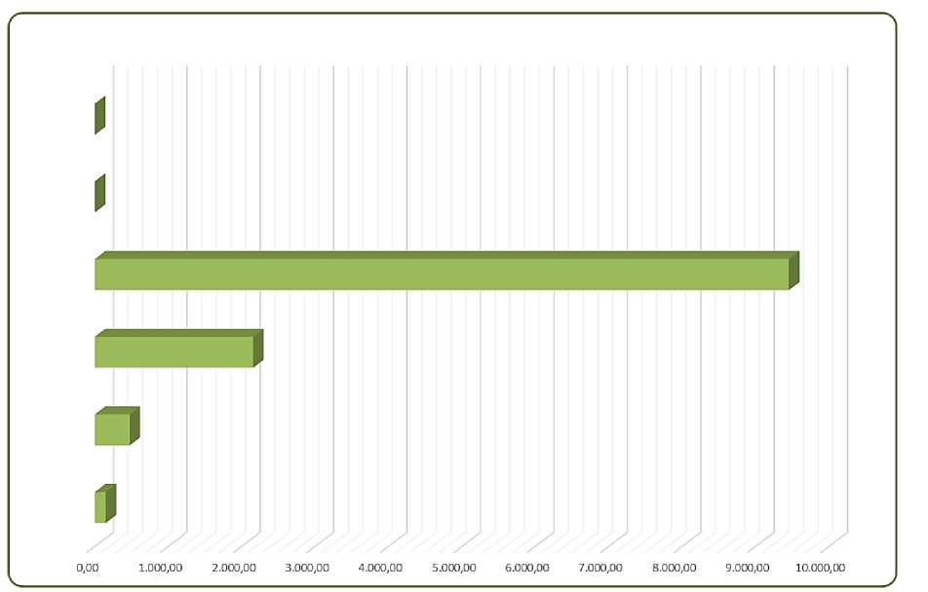
Category 6

Category 5

Category 4

Category 3

Category 2

Category 1
GREENHOUSE GAS EMISSIONS

Figure 1 Distribution of Greenhouse Gas Emissions

Details of distribution of the company’s direct emissions are shared in Figure 2.

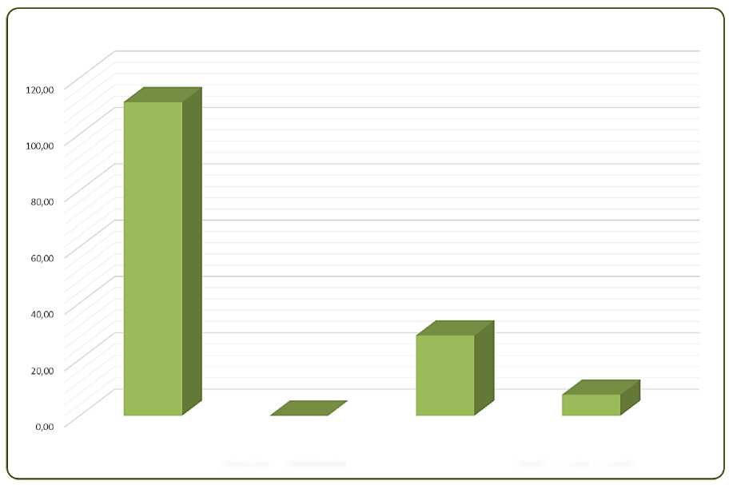
Direct emissions from stationary combustion sources | Direct process emissions and removals from industrial processes | Direct emissions from mobile combustion sources | Direct emissions from leaking/escaping of greenhouse gas in anthropogenic systems

DIRECT EMISSIONS

Figure 2 Distribution of Direct Emissions

Details of distribution of the company’s indirect emissions are shared in Figure 3.

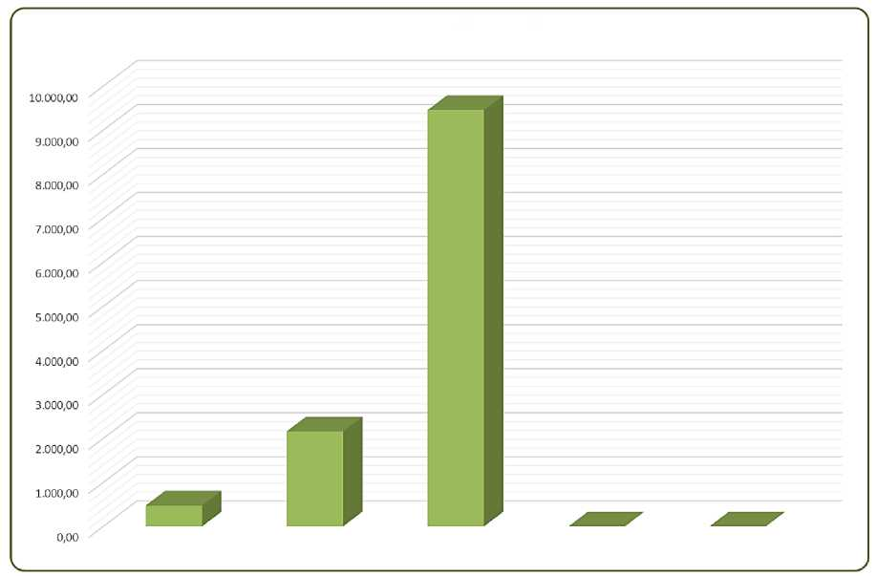
DIRECT EMISSIONS
Category 2 | Category 3 | Category 4 | Category 5 | Category 6

Figure 3 Distribution of Indirect Emissions

Details of distribution of transportation-related emissions are shared in Figure 4.

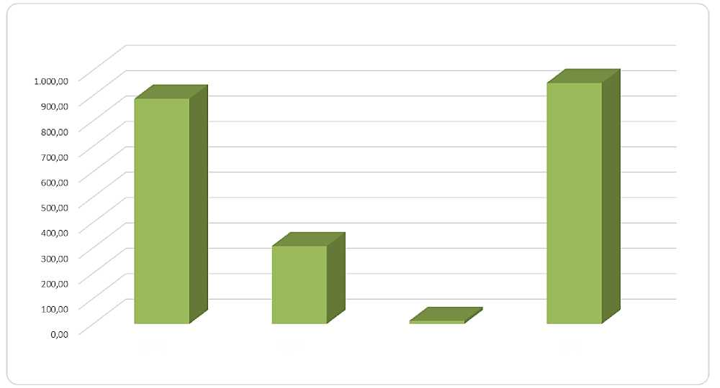
Emissions from transportation or distribution of goods (entering the organization/upstream) | Emissions from transportation or distribution of goods (leaving the organization/downstream) | Emissions related to business travel and visitors | Emissions from employee commuting

TRANSPORTATION-RELATED INDIRECT EMISSIONS

Figure 4 Distribution of Transportation-Related Emissions

Details of distribution of indirect greenhouse gas emissions from products used by the organization are shared in Figure 5.
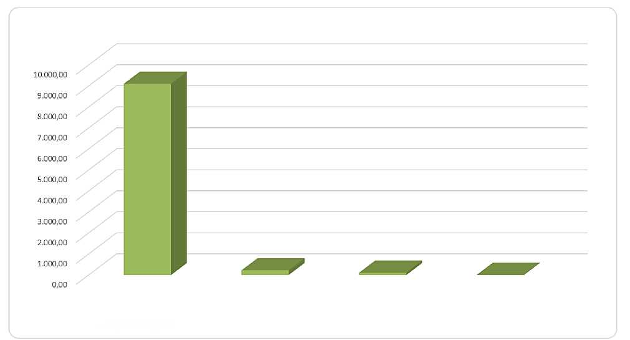
Emissions from purchased raw materials/finished goods/semi-finished goods, etc., related to the manufacturing of the product | Emissions from capital assets (movable & immovable) | Fuel and energy activities | Emissions from disposal of solid and liquid wastes

INDIRECT GHGE FROM PRODUCTS USED BY THE ORGANIZATION

Figure 5 Distribution of Emissions from Products Used by the Organization

Details of distribution of greenhouse gas emissions by subcategory are shared in Table 2.

Table 2 Distribution of Greenhouse Gas Emissions by Subcategory
Category 1 - Direct GHG Emissions and Removals | HCFC (tCO2e) | SF6 (tCO2e) | CO2 | CH4 | N2O | Emissions (tCO₂e) |  | Total (tCO₂e)
Direct emissions from stationary combustion sources | 0.00 | 0.00 | 111.20 | 0.06 | 0.07 | 111.34 | 76% | 147.22
Direct process emissions and removals from industrial processes | 0.00 | 0.00 | 0.00 | 0.00 | 0.00 | 0.00 | 0% | 147.22
Direct emissions from mobile combustion sources | 0.00 | 0.00 | 27.65 | 0.04 | 0.77 | 28.46 | 19% | 147.22
Direct emissions from leaking/escaping of greenhouse gas in anthropogenic systems | 7.41 | 0.00 | 0.01 | 0.00 | 0.00 | 7.42 | 5% | 147.22
Category 2 - Indirect GHGE from imported Energy | HCFC (tCO2e) | SF6 (tCO2e) | CO2 | CH4 | N2O | Emissions (tCO₂e) |  | Total (tCO₂e)
Indirect emissions from imported electricity | 0.00 | 0.00 | 468.74 | 2.04 | 2.70 | 473.47 | 100% | 473.47
Category 3 - Indirect GHGE related to Transportation |  |  |  |  |  | Emissions (tCO₂e) |  | Total (tCO₂e)
Emissions from transportation or distribution of goods (entering the organization/upstream) |  |  |  |  |  | 887.49 | 41% | 2,156.54
Emissions from transportation or distribution of goods (leaving the organization/downstream) |  |  |  |  |  | 306.92 | 14% | 2,156.54
Emissions related to business travel and visitors |  |  |  |  |  | 12.24 | 1% | 2,156.54
Emissions from employee commuting |  |  |  |  |  | 949.88 | 44% | 2,156.54
Category 4 - Indirect GHGE from Products Used by the Organization |  |  |  |  |  | Emissions (tCO₂e) |  | Total (tCO₂e)
Emissions from purchased raw materials/finished goods/semi-finished goods, etc., related to the manufacturing of the product |  |  |  |  |  | 9,106.54 | 96% | 9,454.25
Emissions from capital assets (movable & immovable) |  |  |  |  |  | 224.18 | 2% | 9,454.25
Fuel and energy activities |  |  |  |  |  | 112.66 | 1% | 9,454.25
Emissions from disposal of solid and liquid wastes |  |  |  |  |  | 10.88 | 0% | 9,454.25
Category 5 - Indirect GHGE from Use of Our Products |  |  |  |  |  | Emissions (tCO₂e) |  | Total (tCO₂e)
Emissions arising from processing of sold products |  |  |  |  |  | 0.00 | 0% | 22.64
Emissions and removals from use of sold products |  |  |  |  |  | 0.00 | 0% | 22.64
Emissions from end-of-life treatment of products |  |  |  |  |  | 22.64 | 100% | 22.64
End-of-life treatment of sold products |  |  |  |  |  | 0.00 | 0% | 22.64
Downstream leased assets |  |  |  |  |  | 0.00 | 0% | 22.64
Franchises |  |  |  |  |  | 0.00 | 0% | 22.64
Emissions from investments |  |  |  |  |  | 0.00 | 0% | 22.64
Category 6 - Indirect GHGE from Other Sources |  |  |  |  |  | Emissions (tCO₂e) |  | Total (tCO₂e)
Other Indirect Emissions |  |  |  |  |  | 0.00 | 0% | 0.00

